**National University of Computer and Emerging Sciences **

**Laboratory Tasks 01**

*for*

Web Engineering

*Instructor: Saqib Ameer*

*Email: saqib.ameer@nu.edu.pk*

Spring 2024

**FAST School of Computing**

**Lab Task 1**:

Create a sign-up form on your webpage must including Input Fields (User Name, Email, Phone number, Your message, Button (Submit, Reset).

Make sure to fulfill the following requirements.

1. Add labels and placeholder in all fields.

2. Make field required.

3. Add types to the input fields:

a. For name type=”text”

b. For email type=”email”

c. For phone number type=”tel” and add pattern(as mentioned in placeholder)

4. Add types to the buttons:

a. For submit button type=”submit”

b. For reset button type=”reset”

5. Apply get method with action="dummy.php"

6. Make the form flex(display: flex;)

7. Form should be(display: flex; and flex-direction: column;) 8. Make the form responsive.

9. Use proper padding and margin where required.

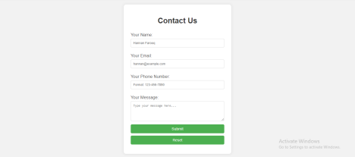

**Lab Task 2**:

Make a replica of the mentioned screen shot of the landing page. Structure of the website is:

<!DOCTYPE html>

<html lang="en">

<head>

<meta charset="UTF-8">

<meta name="viewport" content="width=device-width, initial-scale=1.0"> <link rel="stylesheet" href="styles.css">

<title>Pizza Delight</title>

</head>

<body>

<header>

...

</header>

<section class="slider">

...

</section>

<section class="pizza-specials">

...

</section>

<section class="testimonials">

...

</section>

<section class="cta">

...

</section>

<section class="three-columns"> ...

</section>

<section class="contact-form"> Add the form of task 1... </section>

<footer>

...

</footer>

</body>

</html>

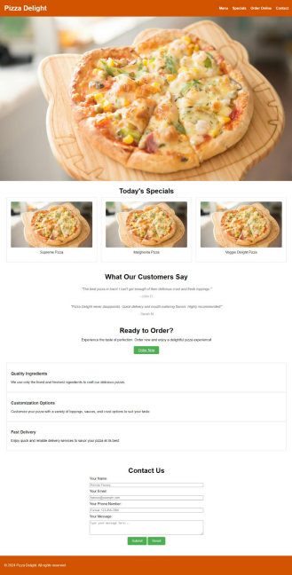

The page should be responsive. Use CSS properties in proper way and try to use classes instead of id. All items of header and buttons should be clickable.

**Visit Link to Practice More About Forms:**

https://www.w3schools.com/html/html_forms.asp

**You are done with your exercise(s), make your submission on Classroom. BEST WISHES**